ISOLATION AND IDENTIFICATION OF AM (ARBUSCULAR MYCORRHIZAL) FUNGAL SPORES FROM THE RHIZOSPHERE SOIL OF MAIZE IN SOME REGIONS OF PATNA (BIHAR).
Author:Nitin Kumar, Research Scholar, Department of Botany, Patna University, Patna Navneet Kumar Mishra, Research Scholar, Patna University, Patna

ABSTRACT
Mycorrhiza is symbiotic mutualism relation between special soil and fungi and fine plant root. They form a fundamental link between biotic and abiotic components of the soil system. The present study aims at isolation and identification of some mycorrhizal fungal spores from the maize field of Patna District of Bihar during 2009-2011. Random collection of rhizospheric soil samples of maize field from Patna, Mithapur, Danapur, Naubatpur and Mokama regions of Patna District was done. Soil samples were collected before and on cultivation of maize plant. Wet sieving and decanting method were employed for the isolation of mycorrhizal spores. Collected rhizospheric soil was suspended in water and passed through sieves of different sizes of 500 ϻm, 250 ϻm, 100 ϻm and 38 ϻm. Spores concentration of different size, shape, colour and hyphal attachment were examined under Stereo microscope. The spore density seemed to be dominated mainly by species of Glomus. However, Gigaspora, Acaulospora, Scutellospora too were identified at comparatively lesser percentage.

INTRODUCTION: -
In 1885 Albert Bernard Frank (Frank, 1885), in his study of soil microbial – plant relationships, introduces the Greek term ‘Mycorrhiza’. Allen (1991) describes the Fungal- plant interaction from a more neutral or microbially oriented aspect stating that ‘Mycorrhiza is a mutualistic symbiosis between plant and fungus localized in a root or root like structure in which energy moves primarily from plant to fungus and inorganic resources move from fungus to Plant’. The group of fungi and plants, which are involved in the interaction, determines the type of mycorrhiza they form (Molina et. al., 1992). Soil microorganisms have significant impact on soil fertility and plant health. Microbial symbionts including arbuscular mycorrhizal (AM) fungi form an essential component of the soil microbial community playing a key role in overall plant growth and development. In addition to increasing the absorptive surface area of their host plant root systems, the extra radical hyphae of AM fungi provide an increased area for interactions with other microorganisms, and an important pathway for the translocation of energy – rich plant assimilates to the soil.
MATERIAL AND METHODS: -
Field survey was conducted during the year 2008, in the different regions of Patna district to determine the soil sample collection sites and status of Vesicular mycorrhizal fungal spores concentration in the soil of those regions. Patna, Mithapur, Danapur, Naubatpur and Mokamaregions of Patna district were selected for soil sample collection sites. Random collection of rhizosphere soil samples of Maize from Patna, Mithapur, Danapur, Naubatpur and Mokamaregion of Patna District was done during 2009-2011.
SOIL SAMPLING BEFORE CULTIVATION: -
Before sowing of maize, soil samples were randomly collected from the respected crop field of each region of Patna district. From each site of the collection, Soil was collected by a small showed from an area of 15 cm diameter of 10 cm depth after the elimination of organic debris and humus particles. For each sample 200 gm soil was collected in transparent polythene bags of 30 cm × 20 cm size and brought into the laboratory and stored at temperature of 4˚ C, for the estimation of mycorrhizal infection rates.
SOIL SAMPLING ON CULTIVATION: -
When above mentioned cereal plants reached at the flowering stage, soil samples were collected from rhizospheric regions of the plants. The collection of rhizosphere soil samples, a whole root system was dug out carefully so as not to lose the terminal and lateral fine feeder roots. A whole root system was shaken off gently and the compact excess mass of soil from the excavated root system was discarded and soil adhering to the root system was retained. 200 gm soil was collected from the soil mass still adhering to a root system in transparent polyethylene bags.
Wet sieving and decanting method are the commonly used method for spore isolation (Gerdemann and Nicolson, 1963; Walker et. al., 1982). Wet sieving and decanting are a simple method which used sieve of various size to separate spores and other similar size particles from sand and clay (Daniels and Skipper, 1982). The various steps involved in wet sieving and decanting method were as follows: -
- First 10 g soil sample was taken and dissolved in 100 ml distilled water in conical flask.
- Then conical flask was shaken for 30 min.
- After that the conical flask was kept in undistributed condition for 30 min.
- The heavier particles were allowed to settle down.
- Suspension was decanted through a 500 ϻm sieve to remove organic matter and roots.
- This suspension was decanted through 250 ϻm, 100ϻm and 38 ϻm sieve consequently.
- The entire residue was collected on 38 ϻm sieve.
- After settlement residue was dissolved in distilled water and filtered through filter paper.
- This paper was spread in Petridis and a residue present in filter paper was taken and mounted on a slide and was examined.

CHARACTERIZATION OF MYCORRHIZAL FUNGAL SPORES: -
Extracted spores were mounted using polyvinyl Alcohol Lactic Acid Glycerol (PVLG) and then morphologically characterized with the help of Manuals (Schneck and Prez, 1990) under Compound Microscope (40 X – 100 X). Major and minor details regarding Shape, Color, Hyphal attachment, for identification unto generic level.The characteristics used for identification include Spore Color, Shape, Size, Wall structure, Ornamental hyphal attachment and Occultation.
PREPARATION OF POLYVINYL ALCOHOL LACTIC ACID GLYCEROL (PVLG): -
Poly vinyl alcohol lactic acid glycerol used in study of vesicular – arbuscular mycorrhizal fungi consists of the ingredients listed below: -
INGREDIENT QUANTITY
Distilled Water 100 ml
Lactic Acid 100 ml
Glycerol 10 ml
Polyvinyl Alcohol 16.6 g

PROCEDURE: -
Polyvinyl Alcohol Lactic Acid Glycerol (PVLG) is used to prepare permanent slides with unbroken and crushed spores, as well as with fragments of Mycorrhizal roots. Its viscosity enables to manipulate the position of the specimen examined and hence accurately determine their properties.
ROOT STAINING TECHNIQUE: -
Root colonization was observed by rapid clearing and staining technique (Philip & Hayman, 1970). For AM colonization assessment root samples were cleared with 10% KOH, acidified with 1N Hcl and stained with Lacto Glycerol Trypan Blue (.05%).
The stained roots were mounted on Microscopic slides and the segment were examined by light Microscope (40 X – 100 X).

ESTIMATION OF VAM ROOT COLONIZATION
VAM root colonization of host plant was studied after processing the roots according to Kaski and Gemma (1989). The total percentage of root colonization was determined by using the formula
$$Root Colonization=\frac{No. of root segment colonized}{Total No. of root segments observed}×100$$
COLLECTION AND STORAGE OF ROOT SAMPLES
- Roots were taken from the regions between 50 cm and 100 cm of root material for each plant species.
- Care was taken to collect as many of the fine lateral roots as possible along with the main system.
- Roots were not collected if they were enlarged with the roots of other species in order to avoid incorrect assessment.
Root samples were placed into labelled vials containing distilled water in order to wash the sand from them. They were generally processed the following day. However, if processing was to be delayed, they were transferred to vials containing 50% ethanol. Ethanol was chosen as the fixative over FAA (Formalin Acetic Acid Alcohol) due to the caustic nature of the latter.

OBSERVATION
Periodical survey of various places such as Patna, Mithapur, Danapur, Naubatpur and Mokama region of Patna district was undertaken to collect and identify different AM fungi Genera and Species association with maize Plant. Rhizosphere soil sample collected from various localities revealed presence of several species of different genera on the basis of resemblances the AM fungi as Glomusspp., Acaulosporaspp. shown in plate.
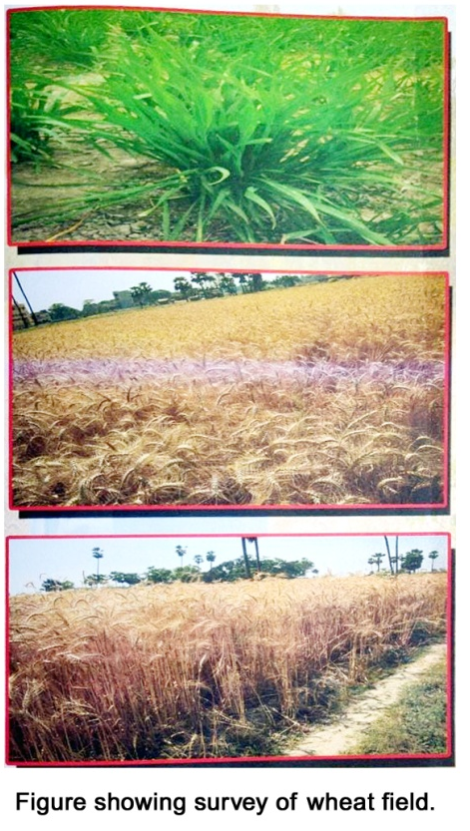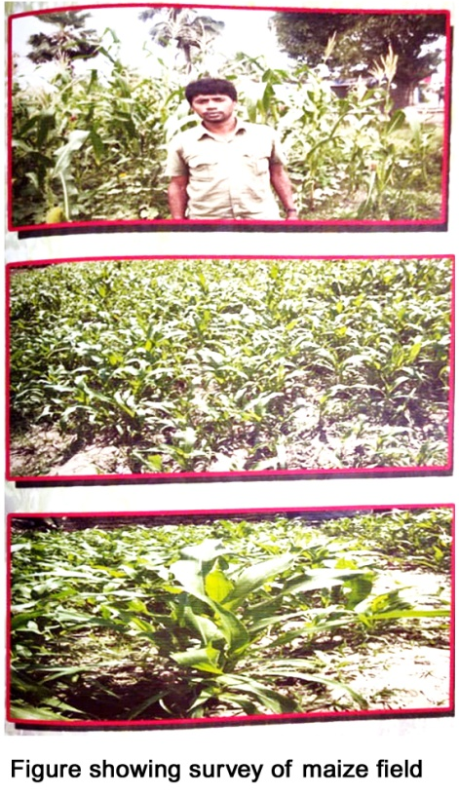
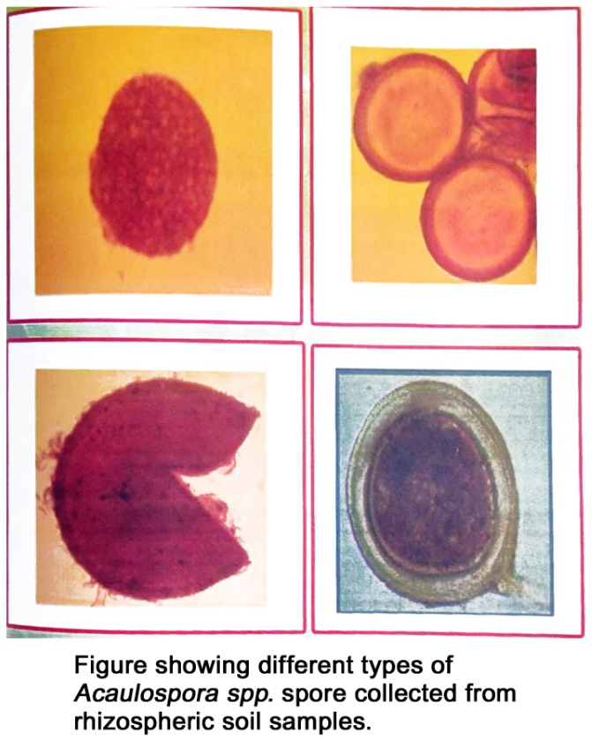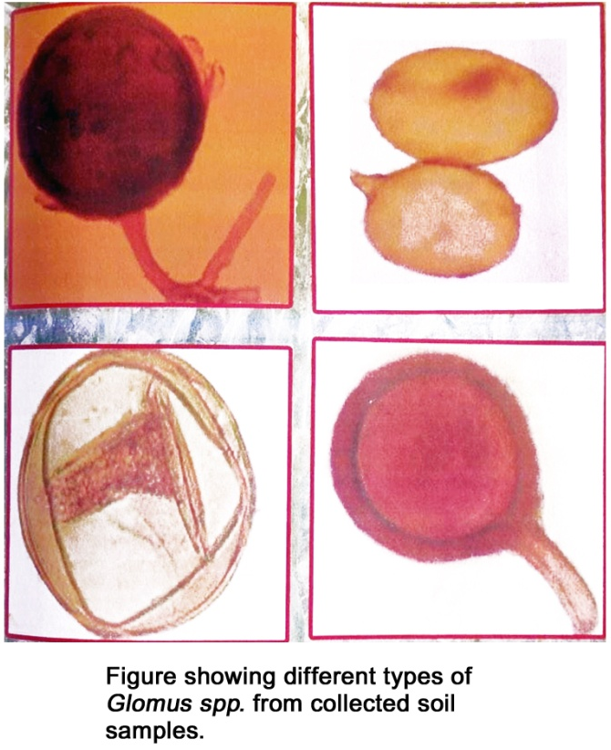

The number of AM fungal Spores isolated from different sites of Maize crop were given in table. The number of AM fungal spores ranged from 80 – 140 per 100 gm of soil. This study describes the distribution of AM fungi in the rhizosphere soil of Maize plant. Both plant and rhizosphere soils were collected during three-year period (2009 – 2011) at different site and during different seasons.
TABLE: - AVERAGE NUMBER OF SPORES AREA WISE AND YEAR WISE
YEAR | PATNA | MITHAPUR | DANAPUR | NAUBATPUR | MOKAMA | AVERAGE SPORE YEAR WISE
2009 | 110 | 110 | 118 | 98.5 | 105 | 108.3
2010 | 122 | 90 | 141 | 132 | 99 | 116.8
2011 | 116 | 112 | 134 | 110 | 112 | 118
AVERAGE SPORES AREA WISE | 116 | 106 | 131 | 113.5 | 105.3

The average number of spores isolated from Maize plant collectively from year 2009 to 2011 from diverse has been show in tabular form table.

Root Infection Assessment: -
In order to find out the potential of AM fungi infection in roots of Maize, the root samples collected from were clean, chopped into small pieces and then subjected to Fixation, Cleaning, Rinsing and Bleaching in KOH solution following standard techniques for Microscopic observations.
In case of infected roots, the presence of AM fungi infection was observed on the basis of root cuts (1 cm size), infected and uninfected, the degree of root infectivity was worked out in term of percentage.
TABLE: - R.C. VALUE OF MAIZE
YEAR | MAIZE PLANT R.C. VALUE
2009 | 16
2010 | 28
2011 | 26

RESULT AND DISCUSSION

In the present study Glomus were the most common Genera and dominant in shifting system. My finding corroborates with the finding of Morton (1988) that the genus Glomus is predominantly distributed genus in the soil all over the world. Glomus were common and made up for more than 75% of total isolates followed by Acaulospora and Gigaspora. Dominancy of Glomus in the present study is in the agreement with the finding of (Panawar and Tarafdar, 2006;Pande and Tarafdar, 2004; Burni and Illahi 2004; Mirtha and Dhar, 2007; Sharma et al, 2009; Burni et al., 2009).In Indian context my finding is corroborate with the finding of Rani and Manoharachary (1994) that the most frequently identified VAM fungi were Glomus spp (7 species).Singh and Adholeya (2002) also observed that the genus glomus was ubiquitous. The predominance of Glomus species under varying soil conditions might be due to the fact that they were widely adaptable to the varied soil conditions and survive in acidic as well as in alkaline soils (Pande and Tarafdar, 2004). In the present study the maximum spores were observed from undisturbed natural vegetation of Danapur of Patna district. The potential reason for maximum number of spore’s availability in undisturbed natural vegetation is that spores keep multiplying in association with plant whereas, in cultivated habitat the top soil is disturbed each time as some fresh crop was sown. Previously several researchers like Gaur and Kaushik 2011, also reported that quantitative spore population differed in cultivated and uncultivated soil. Mycorrhizas are an essential below-ground component in the establishment and sustainability of plant communities, but thorough knowledge is required to achieve maximum benefits from these microorganisms and their associations
REFERENCE
- Allen,M.F., 1991. The ecology of Mycorrhiza.Cambridge: Cambridge University press p 184.
- Brundrett, M.C. (2004) Diversity and Classification of mycorrhizal associations. Bio Rev CambPhilosSoc79 : 473 Doi : 10 . 1017 / SI 464793103006316.
- Burni T., Iftekhar, S., Jocbeen M. and Zainab, S.B. 2009. Diversity of VA (Vesicular Arbuscular) Fungi in some weeds of cauliflower field of Peshawar, Pakistan. Pak J. Pl.Sci. 15 (1): 59 – 67.
- Burni, T. and Illahi, I. 2004.Qualification and correlation of VAM spores with soil characteristics of wheat fields of NWEP. Pak J. pl.Sci.10:139-144
- Daniels, B.A., and Skipper,H. (1982). Methods for the recovery and quantitative estimation of propagules from soil.In: Schenck, N.C. Ed. Methods & Principles of Mycorrhizal Research, American PhytopathologicalSociety,St. Paul,29-35.
- Frank, A.B., 1885, Uber di auf werzelsy- mbiosisberuhendeErnahrunggearsser Baume durchunterirdischeplizeBerDtsch. Bot. Ges. 3: 128-145.
- Gaur S., Kaushik P., 2011 Biodiversity of vesicular arbuscular mycorrhiza associated with Catharanthusroseus, Ocimum spp. And Asparagus racemosus in Utterakhand state of Indian Central Himalaya Int J Bot 7:31-41.
- Gerdemann, J. W., and Nicolson, T.H.(1963). Spores of mycorrhizalEndogone species extracted from soil by wet sieving and decanting. Transactions of the British Mycological Society 46,235-244.
- Koske, R.E., and Gemma, S.N. (1989) A modified procedure for staining roots to detect VA mycorrhizes. Mycological Research 92, 486 – 505.
- Mirtha M.A.U. and Dhar, P.P. 2007. Biodiversity of Arbuscular mycorrhizal colonization and spore population in different Agro forestry tree and crop species growning in Dianajpur Bangladesh. Journal of Forestry Research 18 (2) : 91 – 96.
- Molina, R., Maassicotte, H., and Trappe, J.M. 1992. Specificity phenomena in mycorrhizal symbiosis: community – ecological consequences and practical implications in: Allen, M.F. (ed.), Mycorrhizal functioning: An integrative plant Fungal process Chopman& Hall New york, pp. 357-423.
- Morton,J.B. 1988. Taxonomy of Mycorrhizal fungi: Classification, nomenclature and identification. Mycotaxon32 : 787 – 794.
- Pande, M. and Tarafdar, J.C. 2004. Arbuscular Mycorrhizal fungal diversity in neem-based agroforestry system in Rajasthan. Applied Soil Ecology, 26: 233 – 241.
- Panwar, J. and Tarafdar J.C., 2006. Distribution of three endangered medicinal plant species and their colonization with arbuscular mycorrhizal fungi. Journal of arid environments, 65: 337 – 350.
- Rani, J.S. and Manoharachary, C. (1994). Occurance and distribution of VAM fungi association with saff flower Indian phytopathol Vol.12(3),pp.3-5
- Schenck, N.C. and Perez, Y. (1990) “Manual for identification of VA mycorrhizal fungi”, synergistic publications, Gainesville.
- Sharma, D., Kapoor, R and Bhaytnagar, A.R. 2009. Differential growth response of curculio go orchides to native AMF communities varying in number and fungal components. European Journal of Soil Biology, 45(4):328-333.
- Singh, R., Adholeya, A.2002. Biodiversity of AMF and agricultural potential ii: the impact of agronomic practices Mycorrhiza News,13(4):22-24.
- Sylvia, D.M., Fuhrmann,J.J.Hartel, P.G. Zuberer, D.1998. Principles and application of soil microbiology.Prentice publisher New Jersey.
- Van der Heijden, M.G.A., J.N. Klironomos, M. Ursic, P. Moutoglis, R. Steitwolf-Engel, T. Boller, A. Wicmken and I.R. Sanders 1998. Mycorrhizal fungal biodiversity determines plant biodiversity, ecosystem variability and productivity. Nature 396 (6706):62-72
- Walker,C.M.,Mize,C.,andNcNabb, H.(1982).Population of endogonaceus fungi at two locations in central Iowa. Canadian journal of Botany 60,2518-2529.

